Cyngor Cymuned Gors-las Community Council
Ymhob Braint y mae yna ddyletswydd/ In every privilege there is a duty
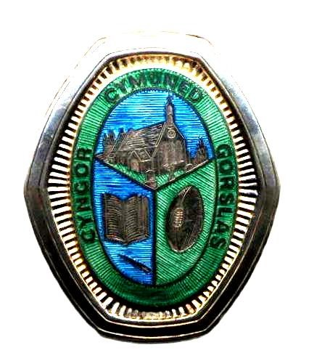
Clerk/Clerc: Llew Thomas
Cyngor Cymuned Gorslas Community Council,
Church Road,
Gorslas SA14 7NF
Carmarthenhire/Sir Gar
Phone/Ffon 0747 9647 763
Email /E Bost :
gorslas.cc.clerk@gmail.com
Rhybydd Cyhoeddus/ Public Notice Cyfarfod Misol Cyngor Cymuned Gors-las Community Council Monthly Meeting
A meeting of the Council which will be held at Cefneithin CP School on Monday 18th March, 2024, at 6.30pm to decide upon the matters detailed below: It will be possible to attend the meeting in person or to access the meeting remotely (contact Clerk a few days in advance to make arrangements).

Mi fydd cyfafod o’r Cyngor yn cael ei gynnal yn Ysgol Cefneithin, ar ddydd Llun 18 o Fawrth, am 6.30.y.h., i benderfynu ar y materion a ddynodir isod. Mi fydd yn bosib fynychu y cyfarfod wrth fod yn gorfforol bresennol neu o bell (cysyllter a’r Clerc diwrnod neu ddau cyn y cyfarfod i drefnu).
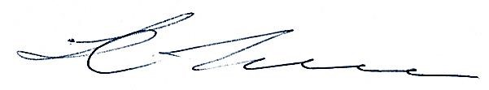
Dated: Dyddiedig 12/03/24
Llew Thomas, Clerk to the Council/Clerc y Cyngor.
AGENDA
- Apologies for Absence/ Ymddiheuriadau am Absenoldeb.
- Declaration of Interests/Datganiadau o Fuddiannau Personol.
- Minutes Previous Meeting: To be considered at next meeting. / Cofnodion cyfarfod blaenorol: I’w ystyried yn y cyfarfod nesaf.
- Opportunity for the Public to address the Council/Cyfle i’r Cyhoedd annerch y Cyngor
- Corporate Matters/Materion Corfforaethol
- To interview aplicants and consider the appointment of Clerk/RFO to the Council/ I gyfweld ymgeiswyr ac ystyried penodi Clerc/SAC I’r Cyngor.
- To consider any transitional arrangements/ I ystyried unrhyw drefnidau trosiannol.
- Next Meeting/ Cyfarfod Nesaf: 08.04.24.

